**Projects:** [**https://citria.org/projects**](https://citria.org/projects)

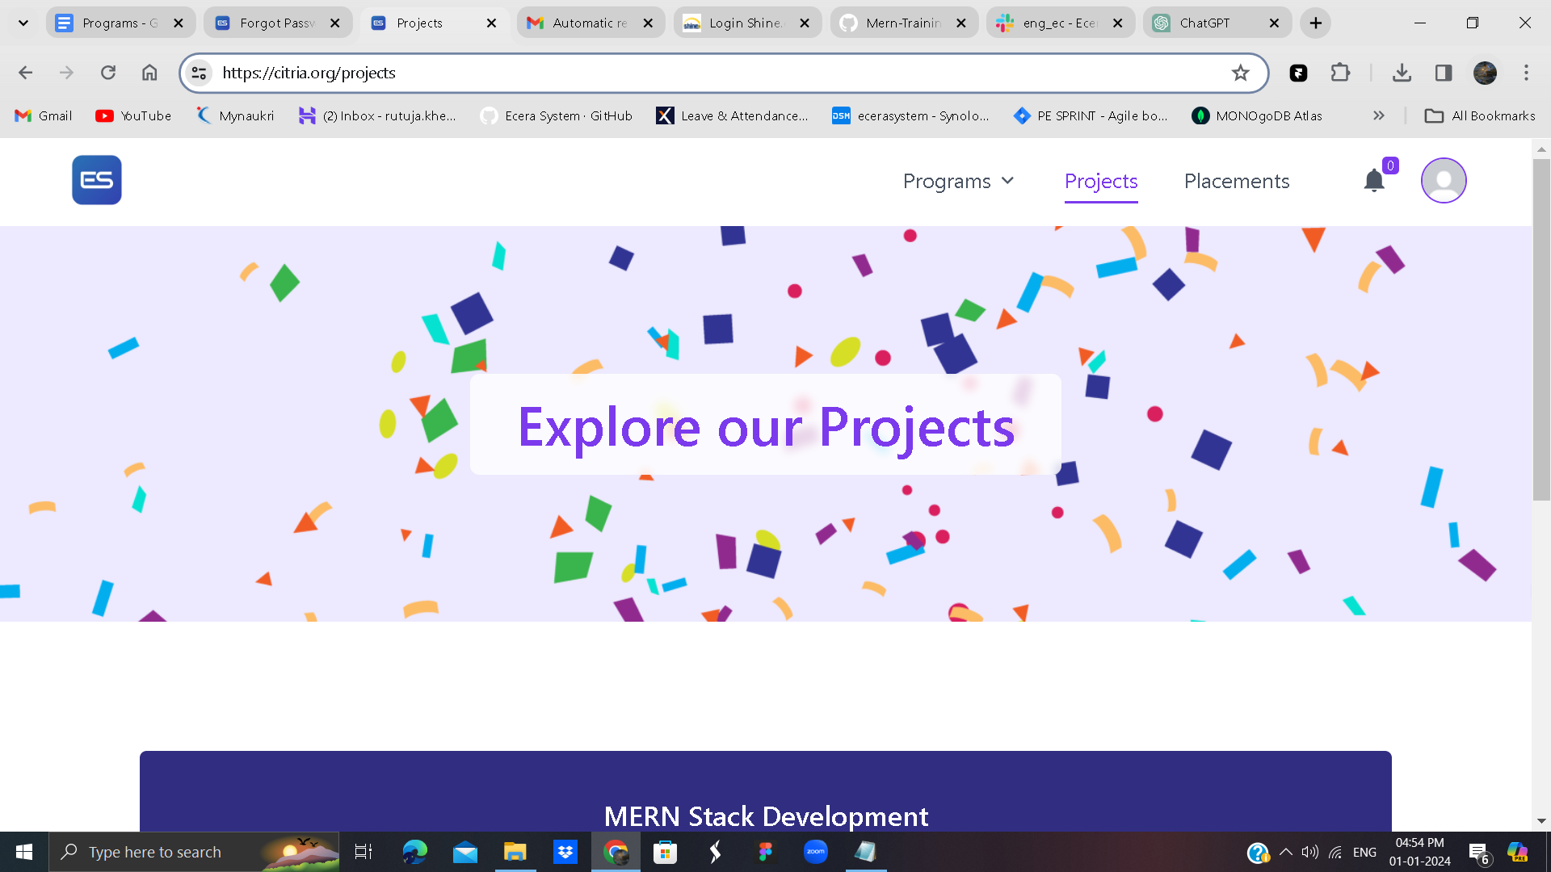

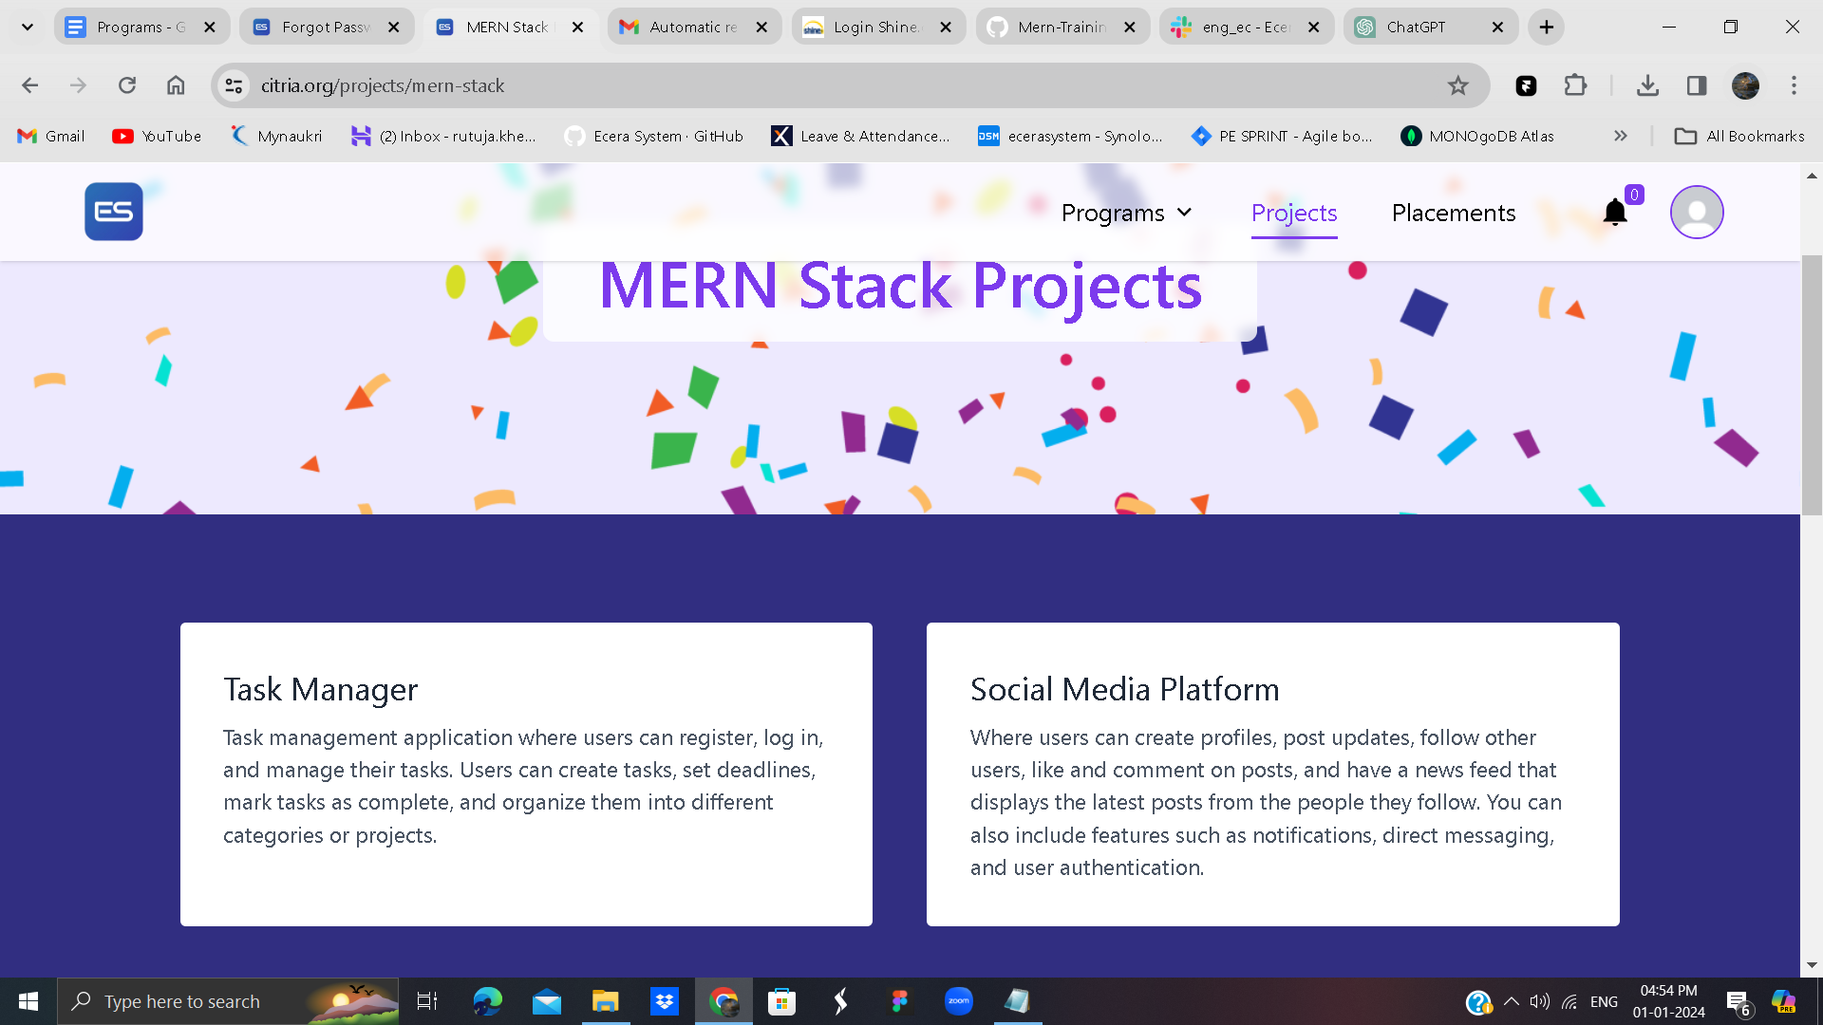

Overview

The MernStackDetails component is a React functional component that represents a section of a web page showcasing MERN (MongoDB, Express.js, React.js, Node.js) Stack Projects. This component is structured to display a page title, header, project sections, and a footer.

Components Used

PageTitle: Displays the title of the page. Imported from '../Shared/PageTitle'.

Header: Represents the header section of the web page. Imported from '../Shared/Header/Header'.

Footer: Represents the footer section of the web page. Imported from '../Shared/Footer/Footer'.

ExploreProjects: A custom component used to explore additional projects. Imported from './ExploreProjects'.

Styling

The component utilizes Tailwind CSS for styling, with classes like bg-violet-100, bg-indigo-900, py-32, etc.

Background images are applied to certain sections, such as the banner section, using inline styling with dynamic image URLs.

Project Sections

The component consists of sections showcasing three MERN Stack projects:

Task Manager:

Allows users to register, log in, and manage tasks.

Features task creation, setting deadlines, marking tasks as complete, and categorization.

Social Media Platform:

Enables users to create profiles, post updates, follow other users, like and comment on posts.

Additional features include a news feed, notifications, direct messaging, and user authentication.

E-commerce Store:

Provides functionalities like product browsing, adding to cart, and making purchases.

Implements features such as product search, filtering, user reviews, product recommendations, and secure payment processing.

ExploreProjects Component

This component is included, and its isTitle prop is set to true, suggesting it may render additional project titles for exploration.

Usage

import MernStackDetails from 'path-to-MernStackDetails';

// Use MernStackDetails component within your application

function App() {

return (

<div>

<MernStackDetails />

</div>

);

}

Conclusion

The MernStackDetails component is designed to provide an engaging and informative representation of MERN Stack projects on a web page. It follows a modular structure, leveraging other custom components for reusability and maintainability. The styling is achieved using Tailwind CSS for a responsive and visually appealing layout.